UG PROGRAM IN ARTIFICIAL INTELLIGENCE AND DATA SCIENCE

MICROPROJECT REPORT | PHASE 3
SMART WASTE CLASSIFICATION
USING COMPUTER VISION

Course: Deep Learning (ADCOR1PC301)

Submitted by:
Tanmay Badhe | Roll No.: 33 | PRN: 124BTAI1026
Swayam Netke | Roll No.: 33 | PRN: 124BTAI1066
Class: TYAIDS-03

Department of Artificial Intelligence and Data Science
Shah & Anchor Kutchhi Engineering College, Chembur - 400088
Academic Year 2026–27

ABSTRACT
This Phase 3 microproject evaluates a computer-vision classifier for six TrashNet waste categories: cardboard, glass, metal, paper, plastic and residual trash. The supplied results archive documents 2,521 cleaned images, split into 1,766 training, 377 validation and 378 held-out test images. Five methods were compared: an HOG/HSV/LBP support vector machine, a convolutional network trained from scratch, and pretrained ResNet-50, MobileNetV3-Large and EfficientNet-B0. Under the predeclared 2-GFLOP edge-selection rule, MobileNetV3-Large was selected. It achieved 94.44% test accuracy (95% bootstrap CI 92.1%–96.6%), macro precision 0.928, macro recall 0.953 and macro F1-score 0.938; ResNet-50 achieved equal test accuracy with 19.0 times more computation. The selected model used 0.431 GFLOPs and 21.7 ms single-thread CPU inference on the reported benchmark environment. The six-class model performed well on held-out photographs, but confidence-gated automatic sorting at threshold 0.90 covered just 28.0% of test images; the remaining images require manual review. INT8 quantization reduced the artifact size to 4.9 MB but degraded accuracy to 51.6%, ruling out that quantized build for use as-is. These results support a promising prototype, not a field-validated smart-bin deployment.

Evidence and experimental provenance
Numerical findings and visuals in this report were extracted from the supplied smart_waste_results.zip archive (model_comparison.csv, split.csv, per_class_report.csv, significance.csv, reject_option.csv, deployment_optimisation.csv and results/figures). The archive includes a trained MobileNetV3-Large checkpoint and an INT8 ONNX export. We checked cross-file consistency, but the underlying experiment was not independently rerun, and the ZIP does not contain the fully executed notebook, individual prediction screenshots or target smart-bin hardware logs. Laboratory CPU latency is not hardware-deployment evidence.

1. INTRODUCTION

1.1 Problem statement
Mixed recyclable and residual waste reduces material recovery and increases reliance on time-consuming manual segregation. Manual inspection can also expose operators to sharp or contaminated objects. The research problem is to determine whether a single RGB photograph is sufficient to identify one visible waste item into a useful material category with a deep-learning model suitable for constrained smart-bin hardware.

1.2 Objectives
- Curate a six-class dataset while reducing leakage caused by duplicate or visually near-identical photographs.
- Benchmark a classical hand-engineered baseline, a scratch CNN and three pretrained convolutional architectures.
- Compare test accuracy, macro precision, macro recall, macro-F1 and confusion matrices using the same held-out data.
- Choose a candidate for edge use by validation macro-F1 under a fixed 2-GFLOP limit, rather than test accuracy alone.
- Study error types, selective human review, Grad-CAM interpretability, CPU latency and ONNX/INT8 feasibility.

1.3 Scope
The classifier accepts one predominantly visible item in a 224 × 224 RGB image. Its label space is exactly cardboard, glass, metal, paper, plastic and residual trash. Organic, sanitary, hazardous, battery and electronic waste are not separately recognised. Mixed piles, full robotic sorting control and live on-device validation remain out of scope.

1.4 Development across phases
Phase 1 framed the waste-management problem and proposed a baseline CNN and lightweight transfer learning. Phase 2 developed the five-model PyTorch workflow and edge-aware evaluation criteria. Phase 3 now adds completed result files, class-level error analysis, confidence-based review, statistical comparisons and a documented deployment limitation from INT8 quantization.

2. DATASET AND SYSTEM DESIGN

2.1 Dataset: TrashNet
The provided TrashNet split file confirms 2,521 cleaned records from the 2,527-source-image dataset (six contradictory duplicates removed); the original six raw class counts shown in Figure 1 remain the dataset reference.
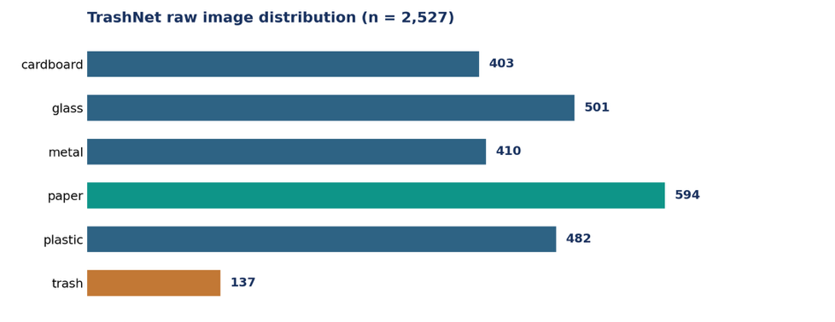
Figure 1. Raw class distribution reported in Phase 2. Total = 2,527; paper is the largest class (594 images) and residual trash the smallest (137 images).
Category | Raw images | Example sorting stream
Cardboard | 403 | Dry recyclable / material-specific
Glass | 501 | Dry recyclable / material-specific
Metal | 410 | Dry recyclable / material-specific
Paper | 594 | Dry recyclable / material-specific
Plastic | 482 | Dry recyclable / material-specific
Trash | 137 | Residual / manual review

2.2 Data integrity and split strategy
- Verify that images open correctly and discard corrupted items.
- Remove exact duplicate files that appear under contradictory class labels.
- Group near-identical photographs and keep each group entirely within one of train, validation or test.
- Target approximately 70% training, 15% validation and 15% held-out test, preserving label balance at group level.
- The uploaded split.csv verifies 2,521 records: 1,766 train (70.05%), 377 validation (14.95%) and 378 test (15.00%). Across 2,502 near-duplicate group identifiers, no group appears in more than one partition. This verifies the split bookkeeping in the provided archive, not every aspect of upstream preprocessing.

2.3 Preprocessing and augmentation
All models use the same image labels and evaluation partition. Neural inputs are resized to 224 × 224 RGB and normalized using ImageNet channel statistics. Training augmentation includes random resized crop, horizontal/vertical flips, ±15° rotations and colour jitter. Validation and test transformations should be deterministic and should not contain random augmentation.

2.4 End-to-end system overview
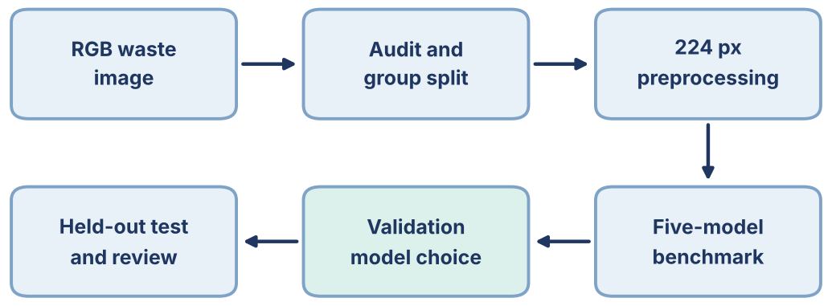
Figure 2. Implemented evaluation workflow: image audit, group-constrained splitting, model training, validation-based selection, final held-out testing and deployment analysis.

3. MODEL ARCHITECTURES AND TRAINING

3.1 Models under comparison
Model | Key architectural idea | Role
HOG + SVM | Handcrafted HOG shape, HSV colour, LBP texture; scaled PCA and RBF-SVM | Classical baseline
Scratch CNN | Five Conv–BatchNorm–ReLU–MaxPool stages and six-class head | Deep learning baseline
ResNet-50 | Pretrained residual network, six-class final head | Higher-compute reference
MobileNetV3-Large | Pretrained mobile-focused architecture | Edge candidate
EfficientNet-B0 | Pretrained MBConv-based efficient architecture | Edge candidate

3.2 Hyperparameters described in Phase 2
Parameter | Configuration
Optimizer | AdamW (neural models); RBF-SVM validation search C = 1, 10, 100
Loss | Class-weighted cross-entropy; label smoothing = 0.10
Learning rate | Scratch/head: 1e-3; fine-tuned pretrained backbone: 1e-4
Batch size | 32
Training plan | Scratch: up to 30 epochs. Transfer: 2 frozen-head warm-up + up to 15 fine-tuning epochs.
Regularization | Weight decay 0.01, dropout 0.30, augmentation
Checkpoint choice | Highest validation macro-F1; early stopping patience 8 scratch / 5 transfer
Efficiency | Mixed precision with GPU where available; measure FLOPs and CPU latency

3.3 Leakage and reproducibility controls
Use a fixed random seed (42), group-constrained splitting before augmentation, training-only loss weights and validation-only hyperparameter tuning. Do not inspect or optimize against the final held-out test labels when choosing the model or the confidence threshold. Record Python/PyTorch/CUDA versions, hardware, train sizes, test sample counts and checkpoint IDs with the scores.

4. EXPERIMENTAL EVALUATION AND SELECTION

4.1 Evaluation indicators
- Accuracy: fraction of correct test predictions across all images.
- Macro precision: unweighted average of class-specific precision across all six labels.
- Macro recall: unweighted average of class-specific recall; useful for class imbalance.
- Macro-F1: unweighted mean of six class F1 scores and primary validation selection metric.
- Confusion matrix: actual class by predicted class; reveals material-specific error patterns.
- CPU latency, parameter count, approximate FLOPs, uncertainty rejection rate and ONNX/INT8 changes: deployment indicators.

4.2 Model selection rule
Among trained neural candidate models with measured computational cost strictly within the 2-GFLOP budget, select the architecture with highest validation macro-F1. Evaluate the locked candidate on the untouched test set. Retain ResNet-50 as a reference if it breaches the budget; do not call it edge-compatible without a verified compute measurement.

4.3 Statistical and operational analysis
Where supported, add bootstrap 95% confidence intervals for test accuracy and macro-F1, paired McNemar tests for competing classifiers, confusion-matrix review, and an analysis of sorting mistakes. Compute confidence-threshold coverage (fraction automatically handled) and error on accepted images using a threshold tuned only on validation predictions. Real-time performance claims require a measured target-device benchmark.

5. RESULTS, ANALYSIS AND FINDINGS

5.1 Results evidence ledger
Result | Source-grounded observation | Status
Cleaned and split image count | 2,521 total; 1,766 train / 377 validation / 378 test | Verified from split.csv
Cross-split near-duplicate groups | 0 of 2,502 groups shared across partitions | Verified from split.csv
Five-model benchmark | Completed: SVM, scratch CNN, ResNet-50, MobileNetV3, EfficientNet-B0 | model_comparison.csv
Selected model | MobileNetV3-Large (under 2-GFLOP limit) | results_summary.md
Selected held-out accuracy | 94.44%; 95% bootstrap CI 92.1–96.6% | model_comparison / significance
Selected macro precision / recall / F1 | 0.928 / 0.953 / 0.938 | per_class_report.csv
Training curves / confusion / Grad-CAM | Generated PNG outputs present | figures/
CPU / INT8 results | 21.66 ms FP32; INT8 test accuracy 51.59% | deployment_optimisation.csv

5.2 Comparative held-out test results
Model | Test accuracy | Macro precision | Macro recall | Macro-F1 | CPU latency
HOG + SVM | 75.13% | 0.733 | 0.752 | 0.740 | 15.9 ms
Scratch CNN | 75.66% | 0.749 | 0.775 | 0.740 | 41.1 ms
ResNet-50 | 94.44% | 0.922 | 0.945 | 0.929 | 122.3 ms
MobileNetV3-Large | 94.44% | 0.928 | 0.953 | 0.938 | 21.7 ms
EfficientNet-B0 | 92.59% | 0.910 | 0.929 | 0.917 | 35.8 ms

The five-model summary above was read from model_comparison.csv. All accuracy and macro-F1 results are measured on the common held-out test set (n = 378). MobileNetV3-Large and ResNet-50 both correctly classified 357 of 378 test images; MobileNetV3-Large has the higher macro F1-score and complies with the 2-GFLOP budget.

5.3 Per-class results: selected MobileNetV3-Large
Class | Precision | Recall | F1 | Test support
cardboard | 0.967 | 0.951 | 0.959 | 61
glass | 0.961 | 0.973 | 0.967 | 75
metal | 0.921 | 0.951 | 0.935 | 61
paper | 0.964 | 0.910 | 0.936 | 89
plastic | 0.957 | 0.931 | 0.944 | 72
trash | 0.800 | 1.000 | 0.889 | 20

5.4 Observed confusion, uncertainty and computational findings
- Training-curve panels are included in Appendix B for all four neural models. They document training/validation trends rather than substitute for held-out evaluation.
- The selected-model confusion matrix reports 21 errors: the largest individual off-diagonal entry is plastic classified as metal (4 images); paper classified as trash also occurs 4 times, followed by cardboard classified as paper (3 images).
- Residual trash achieved 20/20 test recall (100%), but precision was 0.80 because 5 recyclable images were incorrectly predicted as trash. The minority-class sample is small; this is not proof of faultless trash detection.
- The selected architecture requires 4.210 million parameters, 0.431 GFLOPs and 21.66 ms per inference on the supplied single-thread CPU benchmark, versus ResNet-50 at 23.52 million parameters, 8.174 GFLOPs and 122.26 ms.
- With validation-chosen confidence threshold 0.90, 106 of 378 test images (28.0%) are automatically accepted at 100.0% accepted accuracy; 272 are referred for manual sorting. This 106/106 observation is not a general safety guarantee.
- Static INT8 reduced the ONNX artifact to 4.884 MB and reported 18.55 ms CPU latency, but test accuracy collapsed to 51.59% from 94.44% in PyTorch FP32. ONNX FP32 matched accuracy at 8.97 ms in the supplied table, but its 0.34 MB file entry is not independently verified as a standalone weight-complete export; that artifact is absent from the ZIP.

5.5 Key findings supported by executed outputs
Transfer learning substantially improved generalisation: MobileNetV3-Large achieved 94.44% accuracy versus 75.66% for scratch CNN and 75.13% for HOG + SVM. Compared with scratch CNN, the increase is 18.78 percentage points. ResNet-50 matched MobileNetV3-Large accuracy; exact paired McNemar p = 1.000, with a similar result for EfficientNet-B0 (p = 0.2295). Selection was based on validation macro-F1 under the 2-GFLOP constraint, not a statistically proven superiority over all architectures. The selected network recorded 0.0% residual-trash contamination among items routed to recycling, 1.4% recyclable loss into residual waste, and 4.5% cross-material misroutes on the supplied evaluation; these are dataset estimates, not measured waste-facility outcomes.

5.6 Dataset split and statistical comparison
The cleaned dataset includes 403 cardboard, 498 glass, 409 metal, 594 paper, 480 plastic and 137 trash records. The 378-image test subset contains 61, 75, 61, 89, 72 and 20 images respectively. Confidence intervals below are the bootstrap results recorded in significance.csv; McNemar tests compare each rival against MobileNetV3-Large.
Model | Accuracy 95% CI | Macro-F1 95% CI | McNemar p vs selected
HOG + SVM | 0.706 to 0.794 | 0.690 to 0.785 | <0.001
Scratch CNN | 0.712 to 0.799 | 0.692 to 0.784 | <0.001
ResNet-50 | 0.923 to 0.966 | 0.899 to 0.957 | 1.000
MobileNetV3-Large | 0.921 to 0.966 | 0.910 to 0.963 | reference
EfficientNet-B0 | 0.899 to 0.950 | 0.885 to 0.945 | 0.230

5.7 Deployment optimization and confidence-based review
The size/speed trade-off is not sufficient to justify an INT8 deployment: despite the smaller exported file, the quantized model suffers a 42.86-percentage-point drop in held-out accuracy. The FP32 ONNX figure is retained for completeness, but its unexpectedly small 0.34 MB reported file size should be investigated alongside the absent FP32 ONNX artifact before treating it as a standalone deployment deliverable.
Format | Size (MB) | CPU (ms) | Test accuracy | Macro-F1
PyTorch FP32 | 17.04 | 21.66 | 94.44% | 0.938
ONNX FP32 | 0.34 | 8.97 | 94.44% | 0.938
ONNX INT8 | 4.88 | 18.55 | 51.59% | 0.497

At the validation-chosen 0.90 threshold, validation acceptance is 28.9% and test acceptance is 28.0%; all 106 accepted test images were correctly classified, while 272 images remain for manual review. This is a limited-data selective prediction result, not a guarantee of perfect sorting on unseen environmental conditions.

5.8 Visual experiment outputs
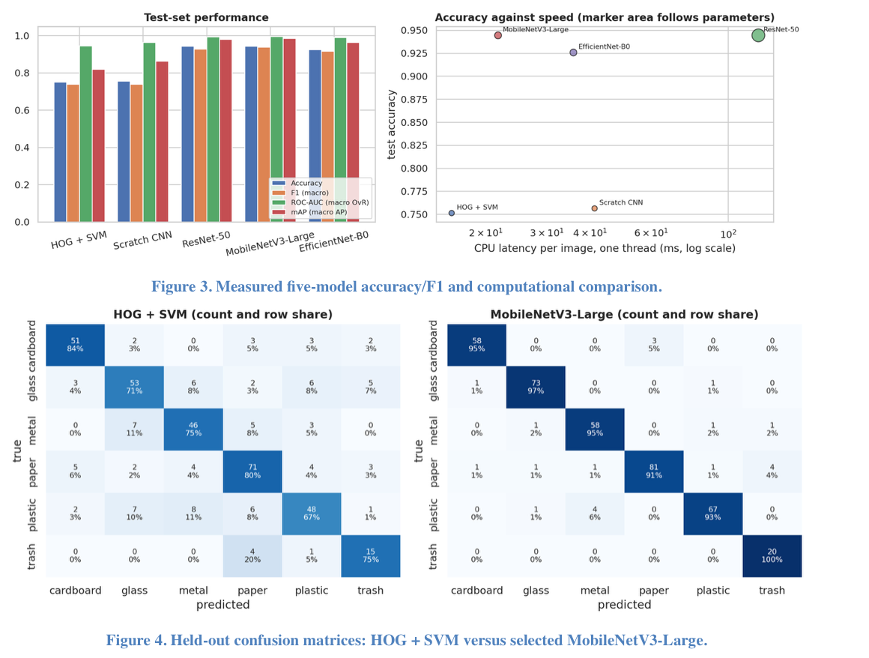
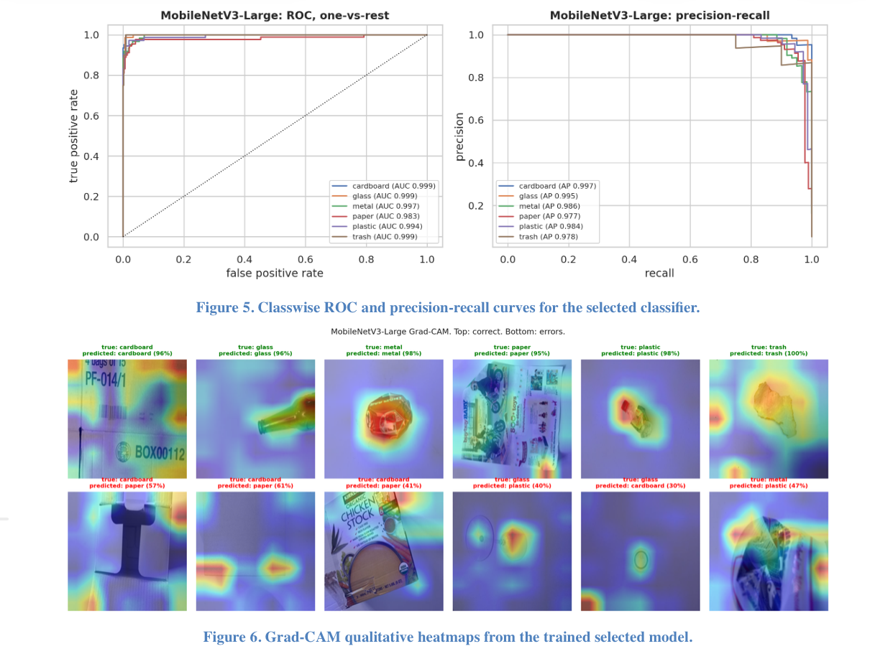
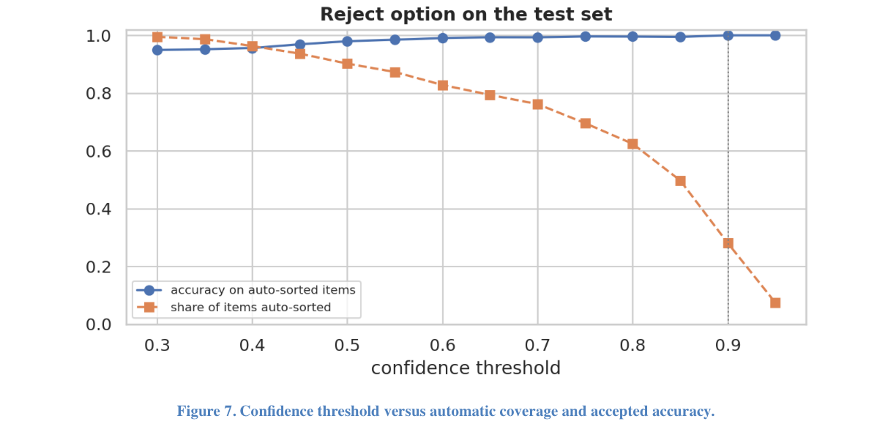

6. TESTING AND VALIDATION

6.1 Functional testing and model demonstration status
Input case | Expected class / action | Observed evidence status | What to inspect
Clear glass bottle photo | glass; dry glass stream | Class-level metrics available; no standalone photo-level run screenshot in ZIP | Confidence and plastic confusion
Cardboard package photo | cardboard; paper/cardboard stream | Class-level metrics available; no standalone photo-level run screenshot in ZIP | Paper vs cardboard confusion
Residual rubbish photo | trash; residual stream | Class-level metrics available; no standalone photo-level run screenshot in ZIP | Minority-class recall
Unclear mixed-material item | Low-confidence flag / human review | Class-level metrics available; no standalone photo-level run screenshot in ZIP | Reject-option correctness

6.2 Prediction function requirements
The ZIP provides model-level evaluation, confusion-matrix and Grad-CAM figures, along with the trained .pt checkpoint. It does not include separate classify(...) screenshots or per-image confidence/top-three probability logs. The example functional scenarios in the table are therefore illustrative. For a practical live demo, run classify(...) on at least three original test photographs, capture the output class, probability and stream recommendation, and note any uncertain or incorrect prediction.

6.3 Acceptance criteria
- No overlapping train and test duplicate groups.
- All five benchmark methods either completed or clearly documented as excluded with a technical reason.
- Metrics and plots computed from held-out predictions, not illustrative numbers.
- Final selected model obeys the pre-declared validation metric and edge-cost rule.
- A human-review fallback exists for uncertain predictions; limitations on harmful material handling are clearly stated.

7. DEPLOYMENT CONCEPT AND LIMITATIONS

7.1 Intended application
A proposed smart-bin pipeline captures a single RGB photo, applies the same 224 × 224 preprocessing, runs MobileNetV3-Large, and displays a suggested material stream only when confidence exceeds the validation-selected threshold of 0.90. On held-out TrashNet images this policy auto-accepted 28.0% at 100% observed accepted accuracy; the remainder was routed for manual decision. It has not been validated on a physical smart-bin controller or complex real-world waste. The quantized INT8 artifact must not be treated as deployment-ready because its measured accuracy fell to 51.6%.

7.2 Limitations and risks
- TrashNet images generally feature one relatively clear item; clutter, poor lighting, wet waste and occlusion can reduce generalization.
- RGB appearance alone may not distinguish visually similar multi-layer or transparent materials.
- TrashNet residual trash is underrepresented (137 source images), which may affect robust per-class learning.
- The label set excludes organic waste despite its appearance in the original Phase 1 proposal.
- A desktop or Colab timing measurement cannot establish actual smart-bin board performance.
- Model errors can contaminate recycling streams; a confidence-based review policy is advisable.

7.3 Environmental and social relevance
The prototype supports the goals of SDG 12, Responsible Consumption and Production, by studying more consistent dry-waste classification. The experiment measures algorithmic accuracy and simulated sorting streams, not real-world recycling rates, worker safety, landfill reduction or emissions. These environmental outcomes require prospective field evaluation.

8. CONCLUSION AND FUTURE WORK
The evaluated six-class waste classifier selected MobileNetV3-Large within the 2-GFLOP edge-compute budget and achieved 94.44% held-out accuracy, 0.938 macro F1-score and a 95% bootstrap accuracy interval of 92.1%–96.6% over 378 images. Its accuracy matched ResNet-50 while using 19.0 times fewer FLOPs and 5.6 times lower measured CPU latency. The strongest errors involved plastic versus metal and paper versus trash. A conservative 0.90 confidence threshold auto-accepted only 28% of images, indicating the importance of manual review for uncertain materials. Although the pretrained FP32 model is a promising computer-vision prototype, the INT8 export lost substantial accuracy and no actual smart-bin hardware trials were supplied. Further calibration, quantization repair and real-world validation are required before physical deployment.

Future work
- Archive the executed Colab notebook with environment/version lines, training logs and model-selection traces for reproducibility; the provided ZIP supplies result files but not that execution trace.
- Collect local real-world photos of Indian waste items and test robustness to lighting, rotation, damage and mixed piles.
- Evaluate out-of-distribution detection, class expansion for special-care waste and human-in-the-loop corrections.
- Repair or retrain post-training INT8 quantization (including representative calibration/preprocessing verification) before edge deployment; benchmark end-to-end latency, size and accuracy on actual hardware.

REFERENCES
[1] G. Thung and M. Yang, “Classification of Trash for Recyclability Status,” Stanford CS229 Project Report, 2016; dataset: https://github.com/garythung/trashnet.
[2] R. A. Aral et al., “Classification of TrashNet Dataset Based on Deep Learning Models,” IEEE International Conference on Big Data, 2018.
[3] K. He, X. Zhang, S. Ren and J. Sun, “Deep Residual Learning for Image Recognition,” CVPR, 2016.
[4] A. Howard et al., “Searching for MobileNetV3,” ICCV, 2019.
[5] M. Tan and Q. V. Le, “EfficientNet: Rethinking Model Scaling for Convolutional Neural Networks,” ICML, 2019.
[6] R. R. Selvaraju et al., “Grad-CAM: Visual Explanations from Deep Networks via Gradient-Based Localization,” ICCV, 2017.
[7] I. Goodfellow, Y. Bengio and A. Courville, Deep Learning, MIT Press, 2016.
[8] PyTorch / torchvision documentation, https://pytorch.org/.
[9] ONNX Runtime documentation, https://onnxruntime.ai/.

APPENDIX A — VERIFIED EXPERIMENT OUTPUTS AND REMAINING EVIDENCE
- Verified in result ZIP: model_comparison.csv with five models and measured test scores; selected model MobileNetV3-Large.
- Verified in split.csv: 2,521 cleaned records with 1,766/377/378 train/validation/test split and zero split-crossing duplicate groups.
- Verified in figures/: per-model training curves, class distribution, image augmentation, model comparison, confusion matrices, ROC/PR plots, Grad-CAM and confidence-coverage curve.
- Verified in per_class_report.csv: six-class precision, recall, F1 and support on the 378-image test set.
- Verified in significance.csv and deployment_optimisation.csv: bootstrap intervals, paired tests, CPU latency and quantization outcomes.
- Still advisable before submission if requested by instructor: attach full executed Colab notebook and 3 sample inference screenshots, with input images and actual predictions.
- Still required before a practical smart-bin claim: test on local mixed/light-variable waste images, validate calibration and deploy on actual target hardware.

APPENDIX B — TRAINING CURVES AND DATA AUDIT FIGURES
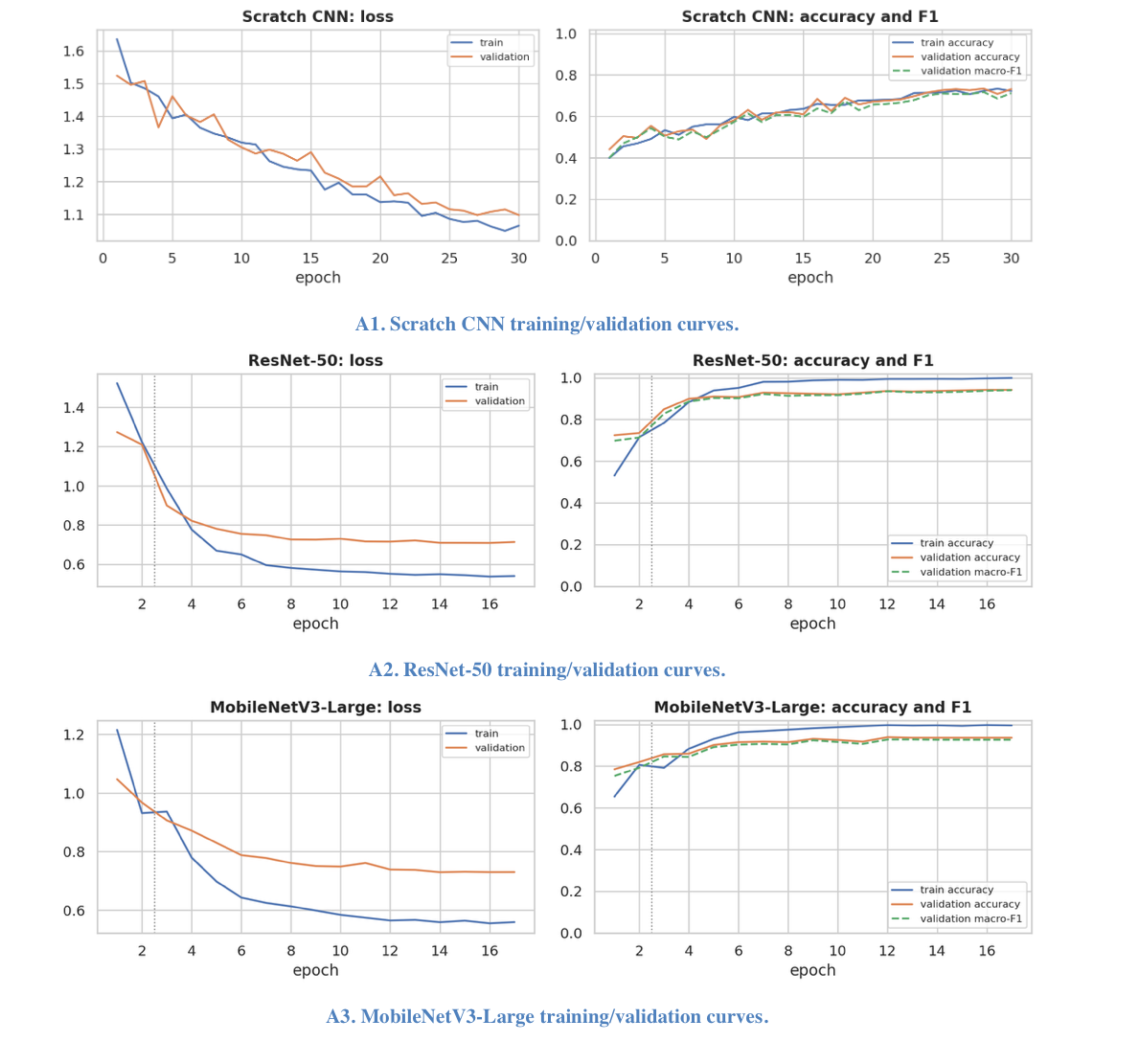
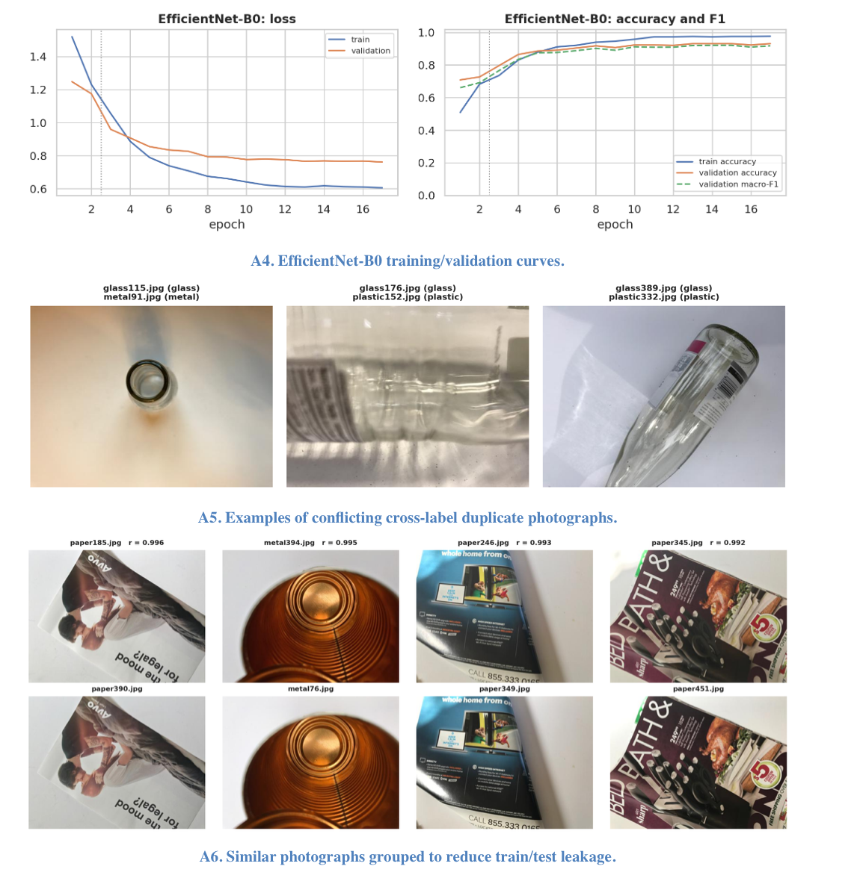

APPENDIX C — FILE PROVENANCE AND LIMITATIONS
Project sources: Phase 1 report (DL-Microproject_Report_TYAIDS-03(1).pdf), Phase 2 report (TYAIDS_03_SLA-phase2.docx) and uploaded smart_waste_results.zip. Result archive contains a selected model .pt checkpoint, selected_int8.onnx, seven CSV/MD files and generated evaluation figures. Numerical conclusions reflect the supplied result artifacts, not an independent rerun. The archive has no executed notebook and no raw test-image prediction screenshot set; these should be attached if the submission rubric demands direct execution evidence.

APPENDIX D — SUPERVISOR SIGN-OFF
Student signatures (Tanmay Badhe, Swayam Netke): ______________________________
Faculty remarks: ______________________________________________________________

